Iterative Clustering

Cluster Comparison

Method | NCluster | CCC | Best
K Means Cluster | 3 | -5.2691
K Means Cluster | 4 | -5.4424
K Means Cluster | 5 | -6.3924
K Means Cluster | 6 | -3.7408
K Means Cluster | 7 | -2.428
K Means Cluster | 8 | -3.2839
K Means Cluster | 9 | 0.16107 | Optimal CCC

Columns Scaled Individually

K Means NCluster=3
Columns Scaled Individually

Cluster Summary

Cluster | Count
1 | 1
2 | 77
3 | 196

Step | Criterion
6 | 0

Cluster Means

Cluster | environment_score | social_score | governance_score
1 | 450 | 667 | 75
2 | 282.727273 | 252.948052 | 222.454545
3 | 519.045918 | 327 | 308.734694

K Means NCluster=4
Columns Scaled Individually

Cluster Summary

Cluster | Count
1 | 171
2 | 28
3 | 1
4 | 74

Step | Criterion
11 | 0

Cluster Means

Cluster | environment_score | social_score | governance_score
1 | 502.654971 | 314.497076 | 305.046784
2 | 610.642857 | 397 | 325.964286
3 | 450 | 667 | 75
4 | 276.364865 | 252.351351 | 220.959459

K Means NCluster=5
Columns Scaled Individually

Cluster Summary

Cluster | Count
1 | 177
2 | 60
3 | 1
4 | 15
5 | 21

Step | Criterion
9 | 0

Cluster Means

Cluster | environment_score | social_score | governance_score
1 | 496.242938 | 315.59322 | 294.717514
2 | 246.016667 | 237.766667 | 219.133333
3 | 450 | 667 | 75
4 | 633.533333 | 429.8 | 316.733333
5 | 543.047619 | 333.142857 | 360.809524

K Means NCluster=6
Columns Scaled Individually

Cluster Summary

Cluster | Count
1 | 153
2 | 15
3 | 60
4 | 13
5 | 32
6 | 1

Step | Criterion
11 | 0

Cluster Means

Cluster | environment_score | social_score | governance_score
1 | 527.071895 | 316.084967 | 300.96732
2 | 549.333333 | 328.866667 | 372.4
3 | 266.566667 | 239.033333 | 213.083333
4 | 635.615385 | 439 | 318.538462
5 | 323.875 | 319.5625 | 283.78125
6 | 450 | 667 | 75

K Means NCluster=7
Columns Scaled Individually

Cluster Summary

Cluster | Count
1 | 39
2 | 4
3 | 32
4 | 8
5 | 138
6 | 52
7 | 1

Step | Criterion
6 | 0

Cluster Means

Cluster | environment_score | social_score | governance_score
1 | 576.435897 | 367.282051 | 310.538462
2 | 651.75 | 517.5 | 348.75
3 | 316.28125 | 320.09375 | 280.90625
4 | 537.625 | 320.375 | 396.75
5 | 518.978261 | 307.565217 | 295.869565
6 | 237.961538 | 229.326923 | 214.269231
7 | 450 | 667 | 75

K Means NCluster=8
Columns Scaled Individually

Cluster Summary

Cluster | Count
1 | 1
2 | 52
3 | 31
4 | 5
5 | 125
6 | 7
7 | 48
8 | 5

Step | Criterion
17 | 0

Cluster Means

Cluster | environment_score | social_score | governance_score
1 | 450 | 667 | 75
2 | 237.961538 | 229.326923 | 214.269231
3 | 314.548387 | 322.548387 | 280.774194
4 | 488 | 222.4 | 281.6
5 | 513.304 | 310.344 | 293.976
6 | 531.428571 | 319.571429 | 402.714286
7 | 579.4375 | 354.0625 | 315.125
8 | 648.4 | 501.6 | 339

K Means NCluster=9
Columns Scaled Individually

Cluster Summary

Cluster | Count
1 | 143
2 | 25
3 | 1
4 | 25
5 | 9
6 | 14
7 | 5
8 | 1
9 | 51

Step | Criterion
9 | 0

Cluster Means

Cluster | environment_score | social_score | governance_score
1 | 526.475524 | 318.86014 | 306.923077
2 | 309.04 | 324.28 | 299.4
3 | 450 | 667 | 75
4 | 451.88 | 308.28 | 226.48
5 | 576.666667 | 330.444444 | 390.888889
6 | 642.714286 | 419.785714 | 310.785714
7 | 488 | 222.4 | 281.6
8 | 505 | 570 | 400
9 | 236.490196 | 227.941176 | 214.254902

Biplot
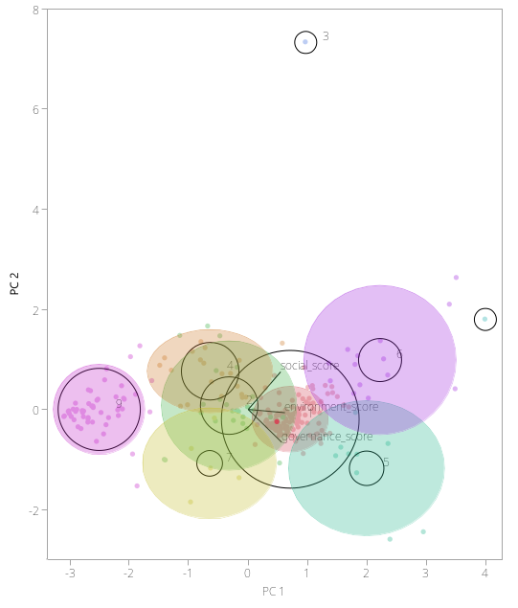

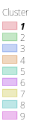

Select principal componentsPC 1PC 2
Eigenvalues

2.1056771 | 0.5817275 | 0.3125953

Scatterplot Matrix
